|  |  |  |  |
| --- | --- | --- | --- |
| C:\Users\David\Dropbox\rossmoyne.png  **Reading Time**: **1 minutes** | **MATHEMATICS METHODS : UNITS 1 & 2, 2019**  Test 2 – (10%)  **(1.1.1 – 1.1.28)** | | |
| **Time Allowed**  20 minutes | | **First Name Surname** | **Marks**  25 marks |

**Circle your Teacher’s Name:** Mrs Benko Mrs Bestall Mrs Fraser-Jones Mrs Goh Mr Koulianos Mrs Murray Mr Rudland

|  |  |
| --- | --- |
| **Assessment Conditions: *(N.B. Sufficient working out must be shown to gain full marks)***   |  | | --- | | * Calculators: Not Allowed * Formula Sheet: Provided * Notes: Not Allowed | |

**CALCULATOR FREE**

1. [3 and 3 marks]

Solve:

$\frac{5y+1}{4}=6-\frac{2y}{3}$

$x^{2}+2x=15$

1. [4 and 5 marks]

Given $x^{3}+3x^{2}-18x-40=(x+a)(bx^{2}+cx-8)$

1. Find the value of *a, b* and *c.*
2. Hence sketch $y=40+18x-3x^{2}-x^{3}$, showing x and y intercepts.

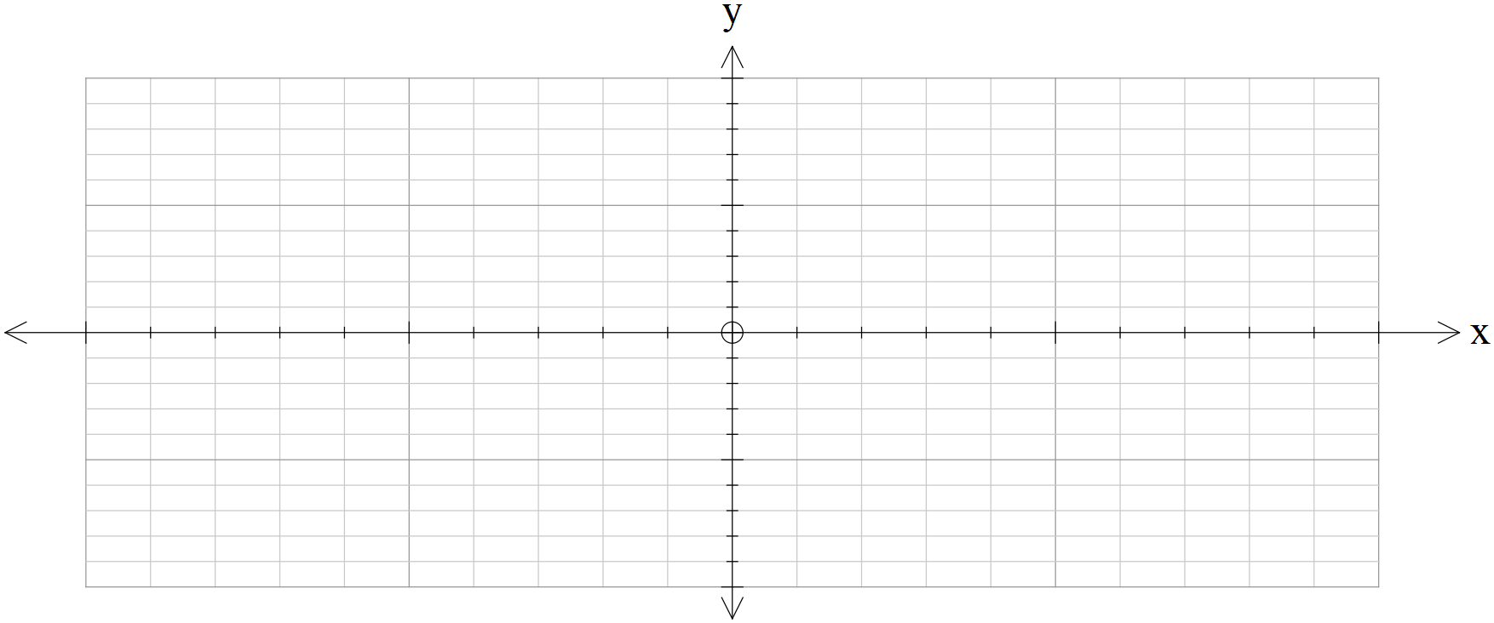

1. [10 marks]

Using the graph supplied, find the value of the constants in each of the equations below:

|  |  |
| --- | --- |
| $${\left(x+a\right)}^{2}+{\left(y+b\right)}^{2}=c$$ a =  b =  c = | $$y=\frac{d}{x+e}+f$$ d =  e =  f = |
| g =  h =  i = | j = |

|  |  |  |  |
| --- | --- | --- | --- |
| C:\Users\David\Dropbox\rossmoyne.png  **Reading Time**: **1 minutes** | **MATHEMATICS METHODS : UNITS 1 & 2, 2019**  Test 2 – (10%)  **(1.1.1 – 1.1.28)** | | |
| **Time Allowed**  25 minutes | | **First Name Surname** | **Marks**  29 marks |

**Circle your Teacher’s Name:** Mrs Benko Mrs Bestall Mrs Fraser-Jones Mrs Goh Mr Koulianos Mrs Murray Mr Rudland

|  |  |
| --- | --- |
| **Assessment Conditions: *(N.B. Sufficient working out must be shown to gain full marks)***   |  | | --- | | * Calculators: Allowed * Formula Sheet: Provided * Notes: Not Allowed | |

**CALCULATOR Assumed**

1. [2 marks)

A relation consists of the ordered pairs: (-3,4) ,(-1,5), (0,-2), (1,4) and (6,8). Is the relation a function? Explain.

1. [5 marks]

Express $y=4x^{2}+8x-7$ in the form $y=a{\left(x+b\right)}^{2}+c$ and hence give its domain and range.

1. [3 marks]

The stress on an object is inversely proportional to its area. If a rectangle measuring 4 metres by 6 metres is under a stress of 60 N/m2. Find the stress a 3 m square would encounter with the same force.

1. [4 marks]

The equation of the path of a cricket ball is $y=1.1x-\frac{x^{2}}{50}$ where *x* and *y* are the horizontal distance travelled and the vertical height respectively in metres. Find, to the nearest the greatest vertical height reached and the horizontal distance travelled.

1. [3 marks]

Find the x-intercept of the line parallel to $5x-2y+10=0$ with a y intercept of (0,-7).

1. [3 marks]

Find the value(s) of *m* if the quadratic equation $x^{2}-2mx+3=0$ has only one solution.

1. [1, 3, 3 and 2 marks]

A(-8,6), B(a,b), C(5,-7) and D(-5,-3) are the vertices of a quadrilateral with diagonals AC and BD.

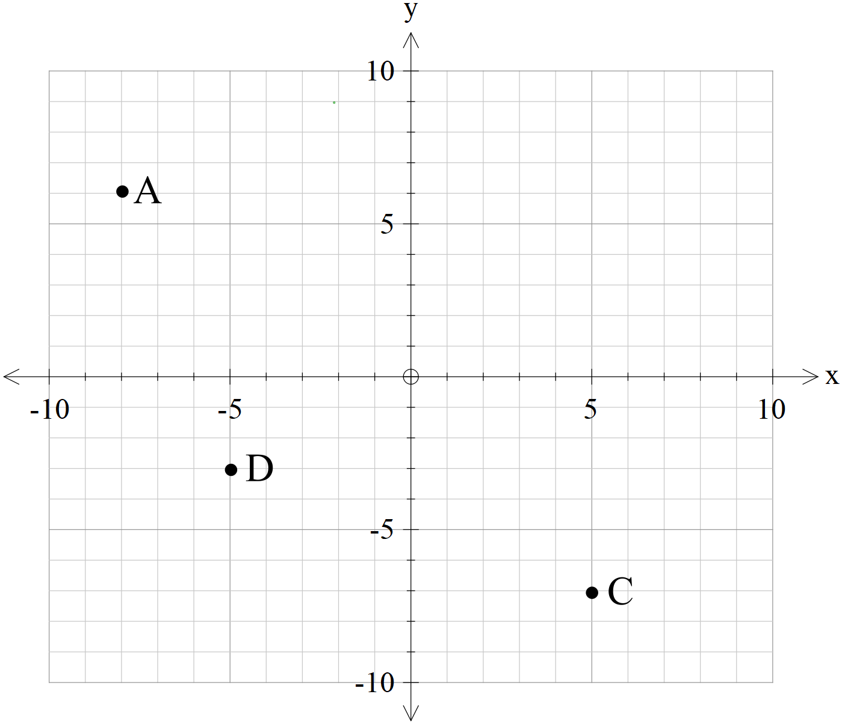

1. Find the mid-point of AC.
2. Find the co ordinates of B, given the diagonals of ABCD bisect each other.
3. Find the equation of the line perpendicular to DC, and passing through D.
4. Does B lie on the line found in question c.